ITAI 4374
Neuroscience as a Model for AI
MODULE 05
Sensory Processing & AI Perception

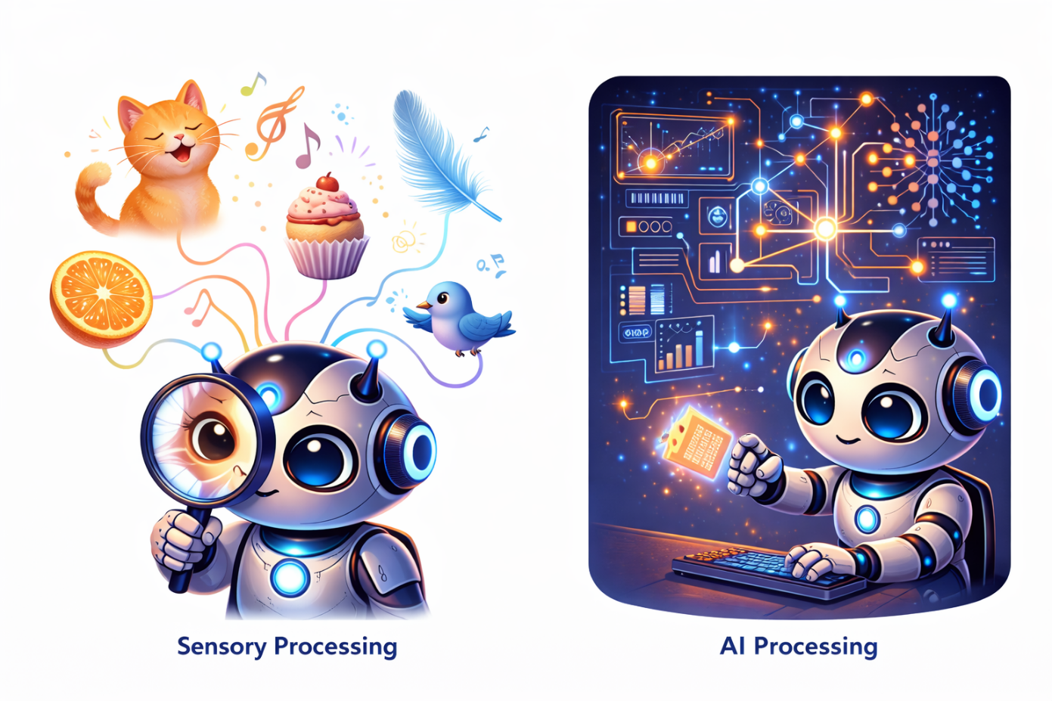

How the Brain Makes Sense of the World — And How AI Tries to Do the Same
Houston City College • Bachelor of Applied Technology in AI & Robotics
Author: Patricia McManus
Spring 2026
Table of Contents

PART 1: HOW THE BRAIN PERCEIVES THE WORLD (Conceptual)
Section 1: Welcome & Module Overview
Section 2: Sensation vs. Perception
Section 3: General Principles of Sensory Systems
Section 4: The Visual System — From Photons to Perception
Knowledge Check #1
Section 5: The Auditory System — Sound as a Model
Section 6: The Other Senses — Touch, Taste, and Smell
Knowledge Check #2
PART 2: FROM BIOLOGY TO AI SYSTEMS (Technical)
Section 7: Hubel & Wiesel → CNNs: The Direct Inspiration
Section 8: Event-Based Vision — Silicon Retinas Meet SNNs
Knowledge Check #3
Section 9: Multimodal Integration — Combining the Senses
Section 10: What Biology Does Better (And Where AI Excels)
Knowledge Check #4
Section 11: Lab Preview
Section 12: Key Takeaways
Section 13: Bridge to Module 06
Section 14: Glossary
Section 15: References & Further Reading

PART 1
How the Brain Perceives the World
SECTION 1

Welcome & Module Overview
Your brain has never seen light.
Really think about that for a moment. Your brain sits in complete darkness inside your skull. It has never directly experienced light, sound, touch, or any other sensation. All it receives are electrical signals — billions of them per second — from sensory neurons that translate physical energy into electrochemical impulses.
Yet somehow, from these electrical signals alone, your brain constructs a rich, colorful, three-dimensional world complete with sounds, textures, tastes, and smells. Everything you have ever experienced — every sunset, every piece of music, every hug — was constructed by your brain from nothing more than patterns of neural activity.
This is the miracle of sensory processing, and it is the subject of Module 05.

1.1 Where We Are in the Course
Let us connect this module to what you have already learned:
🌉 YOUR JOURNEY SO FAR
Module 02: You learned the big theories — Thousand Brains Theory, Predictive Coding — about HOW the brain builds models of the world.

Module 03: You explored the brain's anatomy and met the individual neuron — the Leaky Integrate-and-Fire model, action potentials, neural coding.

Module 04: You connected neurons into Spiking Neural Networks, learned how they train with surrogate gradients, and explored neuromorphic hardware (Loihi 2, DVS cameras).

Module 05 (NOW): You will discover WHAT those neurons are actually processing — how sensory information flows from the outside world through the brain's specialized systems, and how these systems directly inspired the AI architectures you already know.

Module 06 (NEXT): Once information is perceived, how is it stored, retrieved, and learned from? Memory and learning architectures.

1.2 Learning Objectives

By the end of this module, you will be able to:
1. Describe how biological sensory systems convert physical energy into neural representations, using vision and hearing as primary examples.
2. Explain the hierarchical processing architecture of the visual cortex (V1 through IT) and its direct relationship to CNN architecture.
3. Compare visual, auditory, somatosensory, gustatory, and olfactory systems, identifying shared organizational principles.
4. Analyze how biological sensory processing inspired specific AI architectures, including CNNs, spectrograms, and event-based vision.
5. Evaluate the strengths and limitations of both biological and artificial perception systems.

💡 WHY SHOULD YOU CARE?
Every computer vision model you have ever trained is a descendant of neuroscience experiments on cat brains in the 1960s. Every speech recognition system processes sound in ways inspired by the human cochlea. Understanding the biology behind these systems does not just give you historical trivia — it gives you a design toolkit for building better AI.

Companies hiring in bio-inspired AI perception: Tesla (vision-only self-driving), Apple (neural engine for Face ID), Google DeepMind (biological vision research), Prophesee (event cameras), Qualcomm (on-device perception). The intersection of neuroscience and perception AI is where some of the most exciting work is happening.

SECTION 2

Sensation vs. Perception — A Critical Distinction
Before we dive into specific sensory systems, we need to understand a distinction that changes how you think about both brains and AI systems.

2.1 Defining the Terms
 | Sensation | Perception
Definition | The raw transduction of physical energy into neural signals | The brain's constructed interpretation of those signals
Where it happens | At sensory receptors (retina, cochlea, skin) | In cortical processing areas
Relationship to reality | Relatively faithful to physical stimuli | Actively constructed; can be 'wrong' (illusions)
Speed | Fast, automatic | Requires processing time; influenced by context
Example | Light hits retina → photoreceptors fire | You see 'a red apple on a table'

The key insight is that perception is not a passive process. Your brain does not simply receive sensory data and display it like a camera feeding a screen. Instead, perception is an active, constructive process — the brain builds its best guess about what is out in the world based on incomplete, noisy, ambiguous sensory data combined with prior expectations and knowledge.

2.2 The Inverse Problem
Why must perception be constructive? Because sensory systems face what mathematicians call an inverse problem. The brain receives 2D retinal images but must infer a 3D world. A given retinal image could have been produced by infinitely many different 3D scenes. A circle on the retina could be a ball, a flat disc viewed head-on, or the end of a cylinder. Without additional information, the brain cannot know which interpretation is correct.
The brain solves this by using prior knowledge — assumptions about how the world typically works. These priors are built from evolution (millions of years of experience with the physical world) and from personal experience (your lifetime of learning). This is why optical illusions work: they exploit the brain's assumptions, creating situations where the priors lead to incorrect interpretations.
🧠→🤖 AI CONNECTION: The Same Inverse Problem
Computer vision faces exactly the same inverse problem! This is why tasks like depth estimation, 3D reconstruction, and scene understanding are so challenging for AI.

Deep learning has made remarkable progress by implicitly learning priors from massive datasets — similar to what the brain does through evolution and experience. When a CNN correctly identifies an object despite partial occlusion, it is using learned priors about object shapes, just as your brain does.

Generative models (like diffusion models) explicitly learn the distribution of natural images — their 'prior' about what the visual world looks like. This is surprisingly close to what predictive coding theory says the brain does (Module 02).

2.3 Evidence That Perception is Constructed
Timing evidence: Visual processing takes about 100 milliseconds. Yet you can catch a baseball thrown at 90 mph, which moves 12 feet in that time. How? The brain predicts where the ball will be and generates a percept of the predicted position, not the actual position. You literally see a fraction of the future, not the present.
Blind spot evidence: You have a blind spot in each eye where the optic nerve exits — no photoreceptors there. Yet you do not see holes in your visual field. The brain fills in the missing information based on surrounding context. You are literally hallucinating part of your visual field all the time.
Illusion evidence: In the Checker Shadow Illusion (Adelson, 1995), two squares on a checkerboard are identical in physical luminance, but your brain perceives one as much lighter than the other because it 'knows' about shadows and adjusts accordingly. Your perception contradicts the physical measurement.

🔬 TRY THIS: Find Your Blind Spot
1. Cover your left eye.
2. Draw an X and an O about 6 inches apart on paper.
3. Focus your right eye on the X.
4. Slowly move the paper closer or farther from your face.
5. At a certain distance, the O will disappear — that is your blind spot!

Notice that you do not see a hole — your brain fills in the background. This is construction, not reception.

⚠️ MISCONCEPTION ALERT
"We passively receive sensory information like a camera recording the world."

WRONG. Perception is an active, constructive process. The brain generates predictions about incoming sensory data and updates those predictions when they are wrong (prediction errors). This is the core idea of Predictive Coding from Module 02, and you will see it in action throughout this module.

SECTION 3

General Principles of Sensory Systems
Despite processing very different types of physical energy — light, sound, pressure, chemicals — all sensory systems in the brain share a remarkably consistent set of organizational principles. Understanding these principles gives you a framework for understanding any sensory system, and a design toolkit for AI.

3.1 Six Shared Principles
Principle 1 — Transduction: Every sensory system begins by converting a specific type of physical energy into electrical neural signals. Photoreceptors convert light. Hair cells in the cochlea convert sound vibrations. Mechanoreceptors in the skin convert pressure. This conversion is called transduction, and it is the boundary between the physical world and the neural world.
Principle 2 — Hierarchical Processing: Information flows through a hierarchy of processing stages, from simple features to increasingly complex and abstract representations. In vision: edges → contours → shapes → objects → scenes. In hearing: frequencies → spectral patterns → phonemes → words → meaning. Each level builds on the output of the previous one.
Principle 3 — Parallel Pathways: Sensory systems process different aspects of a stimulus simultaneously in separate pathways. Vision splits into 'what' (object identity) and 'where/how' (spatial location and action guidance) streams. Hearing has similar dual streams. Touch separates fine detail from pain and temperature. This parallelism enables efficient, specialized processing.
Principle 4 — Topographic Mapping: Sensory systems preserve spatial or frequency relationships in their neural representations. The visual cortex has a retinotopic map (nearby points in the visual field are processed by nearby neurons). The auditory cortex has a tonotopic map (nearby frequencies are processed by nearby neurons). The somatosensory cortex has a somatotopic map (nearby body parts are processed by nearby neurons).
Principle 5 — Lateral Inhibition: Neurons suppress the activity of their neighbors, sharpening contrasts and enhancing edges. In the retina, center-surround receptive fields make edges pop out. In the cochlea, similar mechanisms sharpen frequency tuning. This biological contrast enhancement is remarkably efficient.
Principle 6 — Top-Down Modulation: Higher brain areas send feedback to lower sensory areas, shaping what we perceive based on expectations, attention, and context. You hear your name across a noisy room (the cocktail party effect). You see faces in clouds. You read misspelled words without noticing. All of these reflect top-down modulation of sensory processing.

🧠→🤖 AI CONNECTION: Which Principles Has AI Adopted?
Principle 1 (Transduction): AI sensors do this — cameras, microphones, LiDAR.
Principle 2 (Hierarchy): CNNs implement this beautifully — the core of deep learning.
Principle 3 (Parallel pathways): Multi-task learning, dual-stream architectures.
Principle 4 (Topographic mapping): Convolutional layers preserve spatial relationships.
Principle 5 (Lateral inhibition): Batch normalization, local response normalization.
Principle 6 (Top-down modulation): Attention mechanisms in Transformers attempt this.

Notice that AI has best implemented principles 1-5 (bottom-up processing) but struggles with principle 6 (top-down modulation). This is a major area of active research and helps explain why AI perception is still more brittle than human perception.

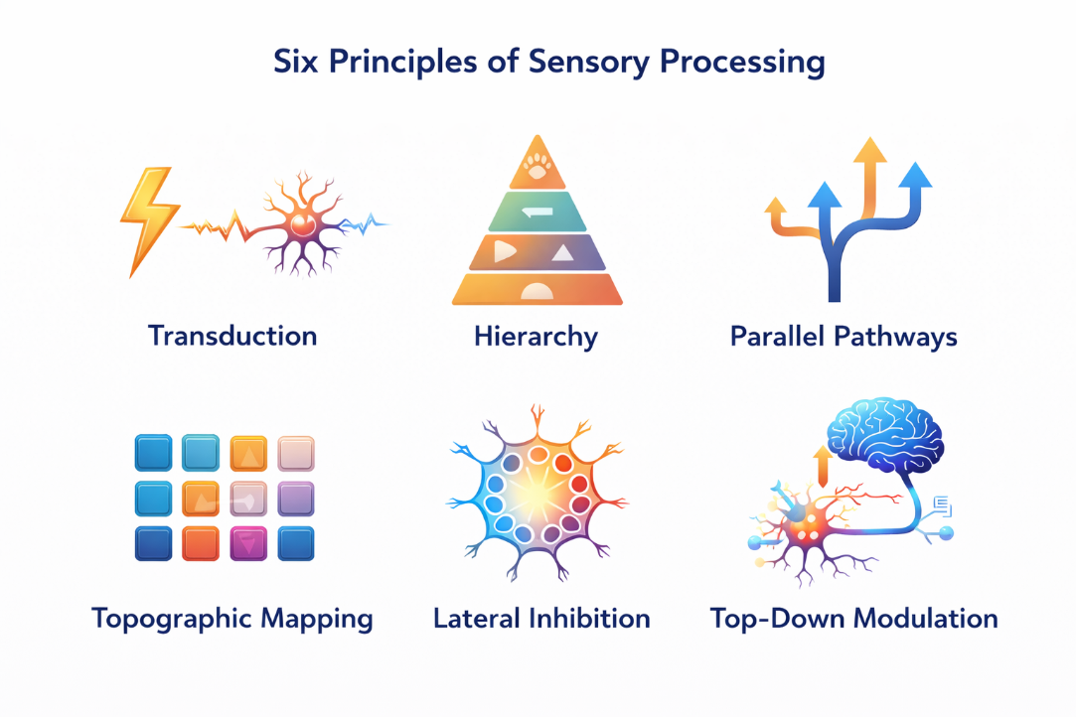
SECTION 4

The Visual System — From Photons to Perception
Vision is the most studied sensory system in neuroscience and the one that has had the greatest impact on AI. About 30% of the entire cerebral cortex is devoted to visual processing — more than any other sensory modality. The story of how the visual system works is also the story of how Convolutional Neural Networks were invented.

4.1 The Retina: More Than a Camera
The retina is a thin layer of neural tissue lining the back of the eye. It is technically part of the brain — it develops from the same embryonic tissue — and it is far more sophisticated than a camera sensor.
Photoreceptors are the cells that convert light into electrical signals. There are two types:
Rods (~120 million per eye): Extremely sensitive to light, responsible for night vision and peripheral vision. They detect brightness but not color. Think of them as high-sensitivity black-and-white sensors.
Cones (~6 million per eye): Responsible for color vision and fine detail. Concentrated in the fovea — the central point of sharpest vision. Three types respond to different wavelengths: short (blue), medium (green), and long (red). All color perception arises from combining signals from these three types.
But the retina does much more than just convert light to electricity. It contains four additional cell types — horizontal cells, bipolar cells, amacrine cells, and ganglion cells — that form a sophisticated local circuit. By the time visual information leaves the eye through the optic nerve (via the axons of ganglion cells), the retina has already performed significant computation.
The most important computation is the center-surround receptive field. Each retinal ganglion cell responds to a small patch of the visual field (its receptive field). ON-center cells are excited when light falls on the center of their field and inhibited by light in the surrounding area. OFF-center cells show the opposite pattern. This arrangement means retinal ganglion cells respond most strongly to edges and contrasts — not to uniform illumination.
Why does this matter? Because edge detection is the first step in visual processing, and the retina does it before the signal even reaches the brain. This is remarkably efficient — it reduces the amount of information that needs to be transmitted through the optic nerve by emphasizing what is informative (edges, changes) and discarding what is redundant (uniform regions).
🧠→🤖 AI CONNECTION: Edge Detection at the Sensor
The retina's center-surround receptive fields are mathematically equivalent to the Laplacian of Gaussian (LoG) filter in image processing — a classic edge detection operation.

In classical computer vision, edge detection (Sobel, Canny) was an explicit preprocessing step. In deep learning, the first convolutional layer of a trained CNN typically learns filters that look very similar to center-surround receptive fields — the network independently discovers the same solution that evolution found.

DVS event cameras (from Module 04) take this even further: each pixel independently detects changes in brightness, just like retinal ganglion cells. The DVS is literally a silicon retina.

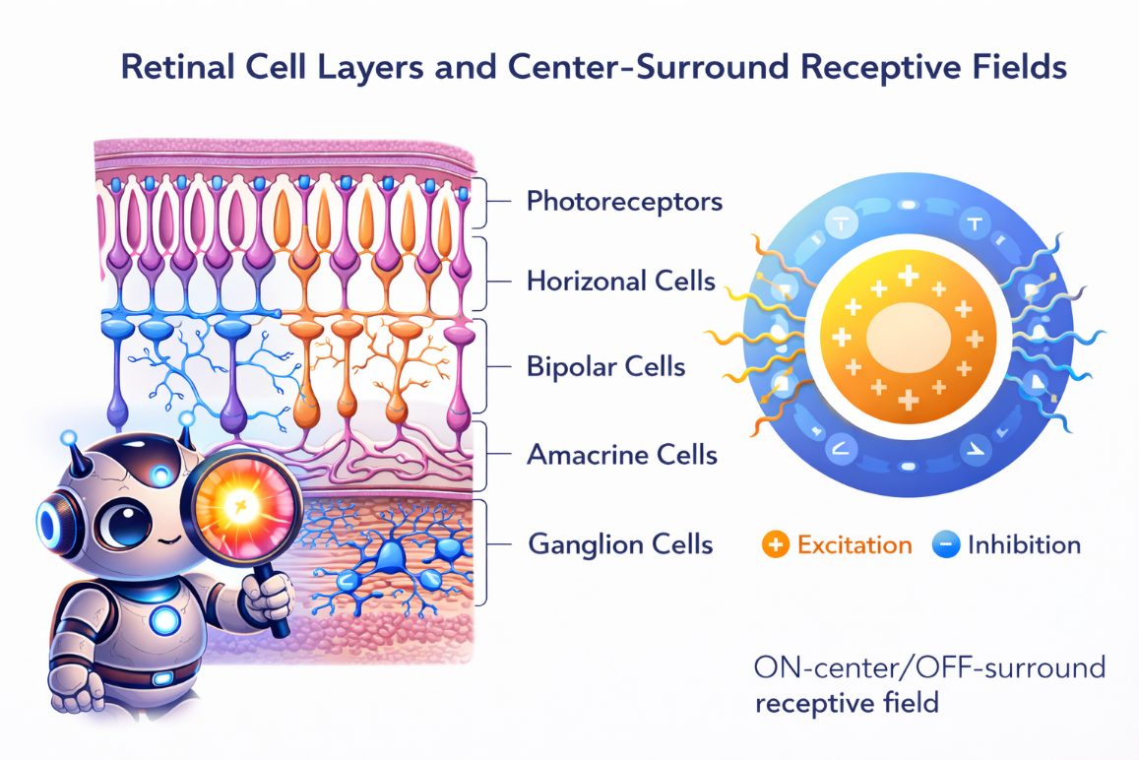

4.2 The LGN: Gateway to the Cortex
From the retina, visual information travels via the optic nerve to the Lateral Geniculate Nucleus (LGN) of the thalamus. The LGN is a relay station — but not a passive one. It has six layers organized into two functional channels:
Magnocellular (M) pathway: Large cells, fast conduction. Processes motion, depth, and low-contrast information. High temporal resolution but low spatial detail. Think of it as the 'fast motion detector.'
Parvocellular (P) pathway: Small cells, slower conduction. Processes color, fine spatial detail, and high contrast. High spatial resolution but slower temporal processing. Think of it as the 'high-resolution detail analyzer.'
These two parallel channels carry different types of visual information from the eye to the cortex. The separation begins in the retina (different types of ganglion cells) and is maintained through the LGN to the visual cortex. This is Principle 3 (parallel pathways) in action — the brain processes motion and detail simultaneously in separate hardware.
🧠→🤖 AI CONNECTION: Multi-Channel Input
Standard CNNs receive RGB channels as input — three parallel streams of color information. The brain's M and P pathways represent a different kind of parallel input: one stream optimized for speed and motion, another for detail and color.

Some modern architectures implement similar ideas: SlowFast networks (Feichtenhofer et al., 2019) use one pathway processing video at low frame rate for detailed spatial features and another at high frame rate for motion — directly inspired by the M/P pathway distinction.

4.3 Primary Visual Cortex (V1): Where It Gets Interesting
From the LGN, visual information projects to the Primary Visual Cortex (V1), located at the very back of the brain in the occipital lobe. V1 is where the story of AI really begins, because the discoveries made here in the 1960s directly led to the invention of Convolutional Neural Networks.

Hubel and Wiesel: The Experiment That Changed AI
In 1958, David Hubel and Torsten Wiesel began a series of experiments at Johns Hopkins University that would earn them the Nobel Prize and fundamentally shape the field of artificial intelligence. They recorded from individual neurons in the visual cortex of cats and monkeys while showing visual stimuli on a screen.
Their key discovery: V1 neurons are selective. They do not respond to just any visual stimulus — each neuron responds best to a specific orientation of an edge (a bar of light) at a specific location in the visual field. Rotate the bar by just 10-15 degrees and the neuron goes silent. Move it to a different location and it goes silent. Each neuron is a highly tuned feature detector.
They identified three types of cells in V1:
Simple cells respond to oriented edges at a specific position. They have clearly defined ON and OFF regions — they are excited by light in some parts of their receptive field and inhibited by light in others. The arrangement of these regions determines the preferred orientation.
Complex cells also respond to oriented edges, but they are position-invariant — they respond to an edge of the correct orientation anywhere within their (larger) receptive field. This is translation invariance, and it is a critical property for object recognition.
Hypercomplex cells (end-stopped cells) respond to edges of a specific length — they are excited by an edge of the right orientation and length, but inhibited if the edge extends beyond a certain size. They detect corners and endpoints.

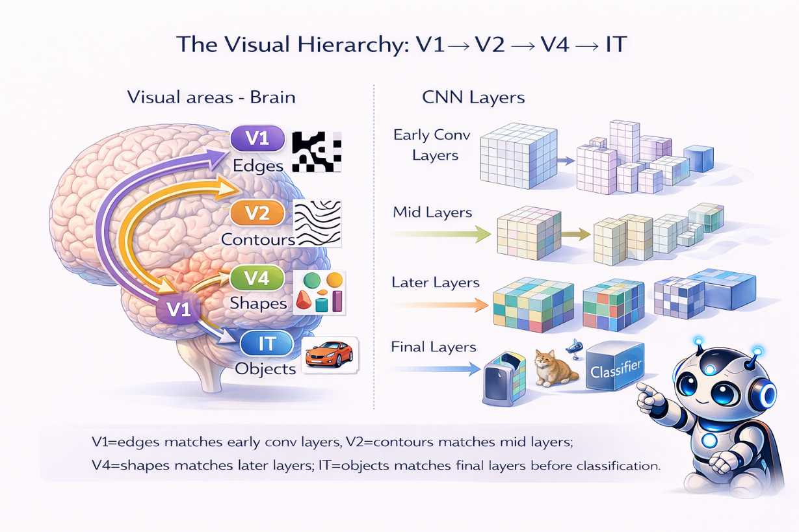

🧠→🤖 AI CONNECTION: The Birth of CNNs
This is THE most direct brain-to-AI inspiration in all of artificial intelligence:

Simple cells = Convolutional filters. Each filter detects a specific oriented edge pattern. The filter is small and is applied at every position — just like simple cells tile the visual field.

Complex cells = Pooling layers. Pooling combines the outputs of nearby convolutional filters, creating responses that are invariant to small shifts in position — exactly what complex cells do.

This is not a loose analogy. Kunihiko Fukushima explicitly cited Hubel and Wiesel when he designed the Neocognitron (1980), the first neural network with convolutional architecture. Yann LeCun built on this for LeNet (1989), and the rest is deep learning history.

4.4 The Visual Hierarchy: V2 → V4 → IT
Beyond V1, visual information flows through a series of higher visual areas, each processing increasingly complex features:
V2: Processes contours, including illusory contours (edges you perceive that are not physically present in the image), texture boundaries, and figure-ground segregation. V2 begins to integrate information from V1 into more meaningful groupings.
V4: Processes shape, color, and intermediate-complexity features. V4 neurons respond to more complex patterns than V1 or V2 — curves, angles, and specific geometric shapes. V4 is also crucial for color constancy (perceiving consistent colors under different lighting conditions).
Inferotemporal Cortex (IT): The end of the ventral visual pathway. IT neurons respond to entire objects, faces, and even specific individuals. This is where the brain recognizes 'what' something is. IT contains the Fusiform Face Area (FFA), specialized for face recognition, and the Parahippocampal Place Area (PPA), specialized for scenes and places.
The hierarchy from V1 to IT shows a clear progression: receptive fields get larger (V1 neurons see a tiny patch; IT neurons respond to stimuli across much of the visual field), feature selectivity gets more complex (edges → shapes → objects), and responses become more invariant to changes in position, size, and viewpoint.

The 'Jennifer Aniston Neuron'
In a remarkable 2005 study, Rodrigo Quiroga and colleagues recorded from neurons in the medial temporal lobe of epilepsy patients (who had electrodes implanted for medical purposes). They found individual neurons that responded selectively to specific people or concepts — one neuron that fired for pictures of Jennifer Aniston (but not other actresses), another for Halle Berry (even when she was in her Catwoman mask), and even one for the Sydney Opera House.
These are not truly 'grandmother cells' (single neurons solely responsible for recognizing one thing). Rather, they represent a sparse, distributed code where each concept activates a small number of neurons, and each neuron participates in representing a small number of concepts. But they dramatically illustrate how far visual processing progresses — from oriented edges in V1 to individual identity in IT.

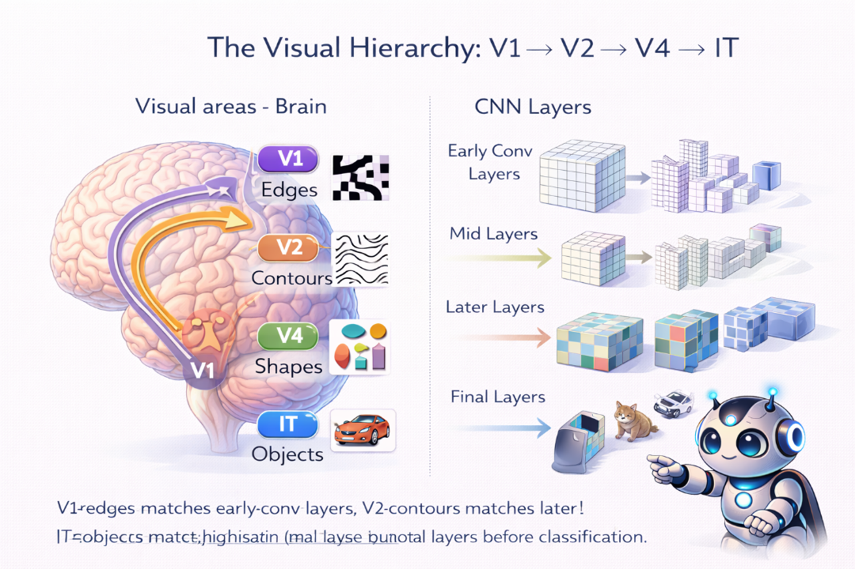

4.5 Two Visual Streams: What vs. Where
From V1, visual information splits into two major processing streams:
The Ventral Stream ('What' pathway): V1 → V2 → V4 → IT → temporal cortex. This pathway processes object identity — what something is. It handles shape recognition, face recognition, color, and fine detail. Damage to this pathway causes visual agnosia — the inability to recognize objects despite being able to see them.
The Dorsal Stream ('Where/How' pathway): V1 → MT/V5 → parietal cortex. This pathway processes spatial information — where things are and how to interact with them. It handles motion perception, depth, spatial relationships, and visually guided action (reaching, grasping). Damage causes optic ataxia — inability to accurately reach for objects despite being able to see and identify them.
The most compelling evidence for this dual-stream architecture comes from double dissociations in neurological patients:
Patient D.F. (ventral stream damage): Could not recognize objects or describe their orientation, but could accurately reach out and grasp them with the correct hand orientation. Her dorsal stream guided her actions even though her ventral stream could not tell her what she was grasping.
Patient A.T. (dorsal stream damage): Could recognize and describe objects perfectly, but could not accurately reach for them. She knew what the object was but her brain could not guide her hand to interact with it.

🧠→🤖 AI CONNECTION: Two Streams in AI
Most computer vision systems implement only the ventral stream — they answer 'what is this?' (image classification, object detection). Very few AI systems implement the dorsal stream — 'where is it and how should I interact with it?'

This is why robotics is harder than image classification. A robot needs both streams: the ventral stream to identify a cup and the dorsal stream to guide its gripper to pick it up. Embodied AI research is increasingly recognizing the need for dual-stream architectures.

SLAM (Simultaneous Localization and Mapping) in robotics is essentially a dorsal stream function — processing 'where' without necessarily knowing 'what.'

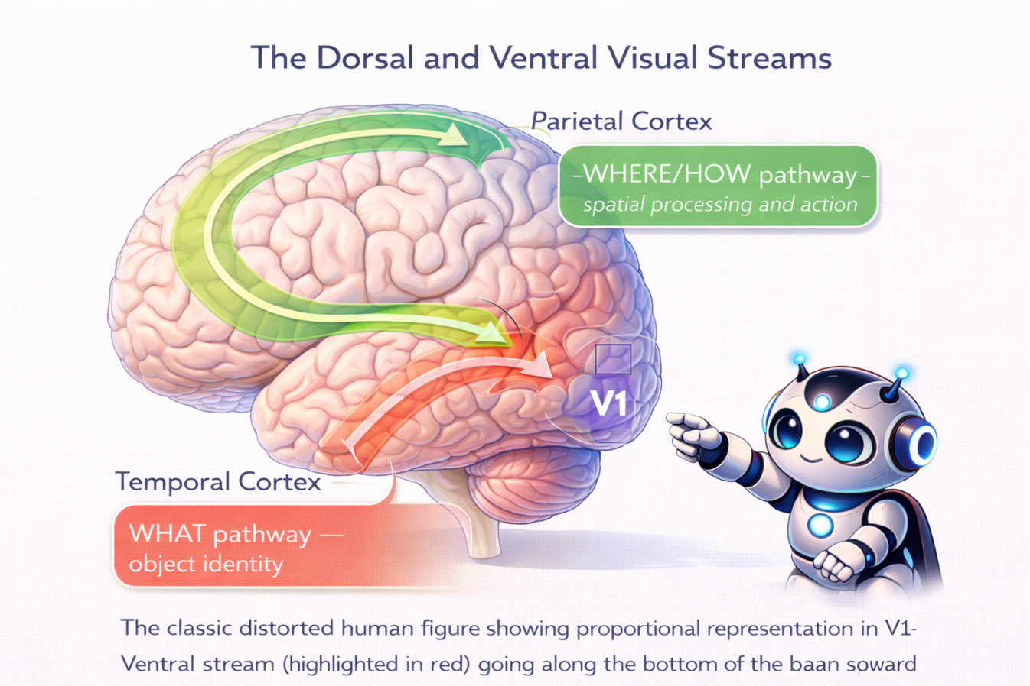

✅ KNOWLEDGE CHECK #1
1. What is the difference between sensation and perception? Give an example of each.
2. What type of receptive field do retinal ganglion cells have, and what computation does this perform?
3. Hubel and Wiesel discovered three types of cells in V1. Name them and describe what each responds to.
4. Which V1 cell type corresponds to convolutional filters in a CNN? Which corresponds to pooling layers?
5. A patient can identify objects but cannot reach for them accurately. Which visual stream is likely damaged — ventral or dorsal?
(Answers in class discussion)

SECTION 5

The Auditory System — Sound as a Model
While vision has received the most attention in AI research, the auditory system offers equally fascinating parallels — and reveals a different set of solutions to the general problem of sensory processing. Hearing also demonstrates that the six principles we outlined apply across modalities.

5.1 From Sound Waves to Neural Signals
Sound consists of pressure waves traveling through air. When these waves reach the ear, they travel through the ear canal to the eardrum, which vibrates. These vibrations are transmitted through three tiny bones (the ossicles) to the cochlea, a snail-shaped structure in the inner ear filled with fluid.
The cochlea is the auditory equivalent of the retina. Inside it, a structure called the basilar membrane vibrates in response to different frequencies of sound. Crucially, different positions along the basilar membrane respond best to different frequencies — high frequencies at the base (near the entrance), low frequencies at the apex (the tip of the snail).
This spatial arrangement is called tonotopy — the auditory equivalent of retinotopy in vision. Just as the retina maps spatial position, the cochlea maps frequency.
Hair cells are the auditory equivalent of photoreceptors. They sit on the basilar membrane and convert its vibrations into electrical signals. When the basilar membrane moves, tiny hair-like projections (stereocilia) on top of the hair cells bend, opening ion channels and generating electrical signals. There are about 15,000 hair cells in each cochlea — compared to 126 million photoreceptors in each retina — making hearing a much sparser sense than vision.
Unlike photoreceptors, hair cells do not regenerate. This is why noise-induced hearing loss is permanent — once hair cells are damaged, they are gone forever. Birds and fish can regenerate hair cells; understanding why mammals cannot is an active area of research.

🧠→🤖 AI CONNECTION: Frequency Decomposition
The cochlea performs a biological Fourier transform — it decomposes complex sound waves into their frequency components, with each position along the basilar membrane responding to a different frequency.

In AI audio processing, the first step is almost always a similar frequency decomposition: the Short-Time Fourier Transform (STFT) or Mel-frequency analysis. When you create a Mel spectrogram for a speech recognition system, you are doing computationally what the cochlea does biologically.

The Mel scale itself was designed to match human frequency perception — it spaces frequencies the way the cochlea does, with finer resolution at low frequencies and coarser resolution at high frequencies.

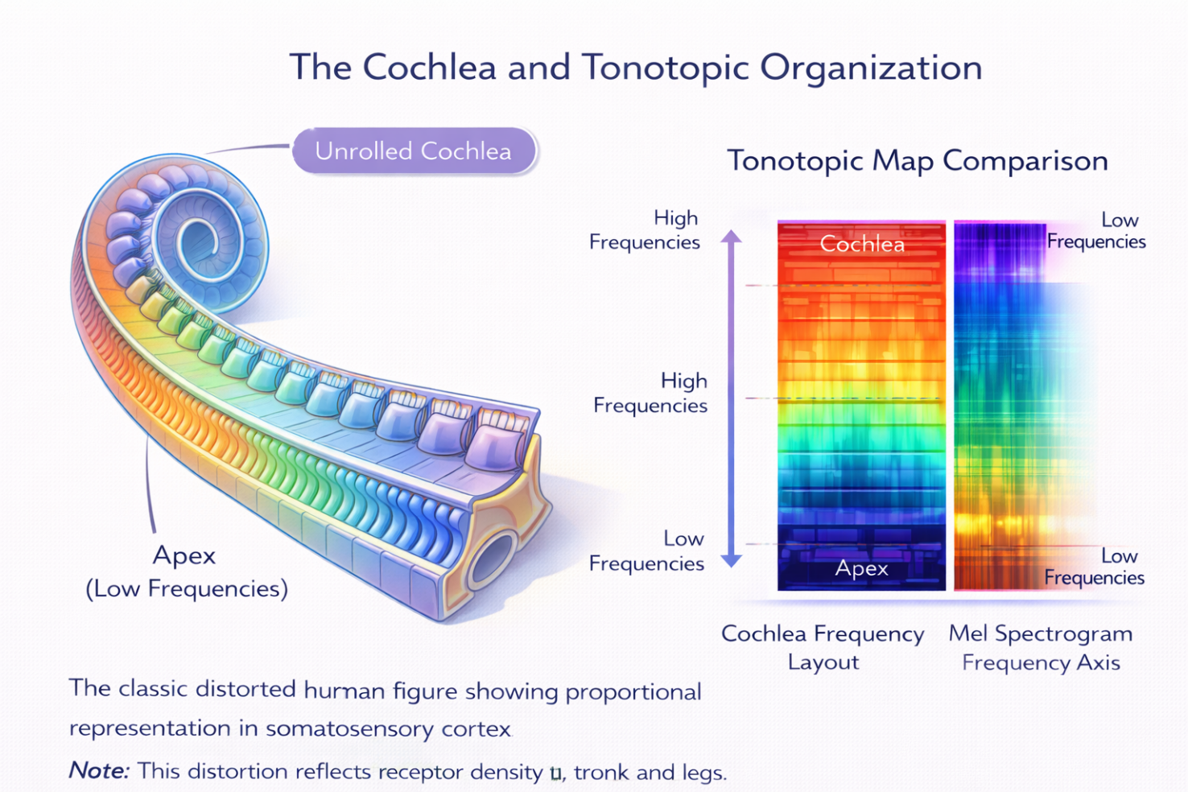

5.2 The Auditory Pathway
From the cochlea, auditory information travels through a series of brainstem nuclei before reaching the cortex:
Cochlear Nucleus: The first relay station. Different cell types here begin processing temporal patterns, onset/offset detection, and spectral features. Some cells respond to the beginning of a sound, others to steady-state sounds, others to changes in frequency.
Superior Olivary Complex (SOC): This is where binaural processing begins — comparing signals from both ears. The SOC calculates two critical cues for sound localization: interaural time differences (ITD — which ear hears the sound first) and interaural level differences (ILD — which ear hears it louder). These computations require microsecond precision.
Inferior Colliculus: A major integration center that combines inputs from multiple brainstem nuclei. It creates a spatial map of auditory space and integrates auditory information with other sensory modalities — particularly vision, for orienting toward sounds.
Medial Geniculate Nucleus (MGN): The thalamic relay for audition (equivalent to the LGN for vision). Relays information to the auditory cortex while also receiving feedback from it.
Primary Auditory Cortex (A1): Located in the temporal lobe. Maintains tonotopic organization — neurons are arranged by their preferred frequency. A1 neurons respond to specific frequency combinations, frequency sweeps, and amplitude modulations.
Beyond A1, auditory information flows to belt and parabelt areas that process increasingly complex sounds — speech, music, environmental sounds, and emotional vocalizations. Like vision, auditory processing splits into two streams:
Auditory Ventral Stream ('what'): Processes sound identity — speech recognition, music recognition, identifying environmental sounds. Flows forward along the temporal lobe.
Auditory Dorsal Stream ('where'): Processes sound location and interfaces with motor systems for sound-guided behavior. Flows toward the parietal cortex.

5.3 Comparing Visual and Auditory Systems
The parallels between these two systems reveal fundamental principles of sensory processing:
Feature | Visual System | Auditory System
Physical stimulus | Electromagnetic waves (light) | Mechanical waves (sound)
Receptors | Photoreceptors: 126 million per eye | Hair cells: 15,000 per cochlea
Transduction organ | Retina (part of CNS) | Cochlea (peripheral)
Topographic mapping | Retinotopy (spatial position) | Tonotopy (frequency)
Thalamic relay | Lateral Geniculate Nucleus (LGN) | Medial Geniculate Nucleus (MGN)
Primary cortex | V1 (occipital lobe) | A1 (temporal lobe)
Processing streams | Ventral ('what') + Dorsal ('where/how') | Ventral ('what') + Dorsal ('where')
Temporal resolution | ~25-50 ms (moderate) | ~1 ms (excellent)
Spatial resolution | Excellent (high acuity) | Moderate (sound localization)
Regeneration | Photoreceptors: limited | Hair cells: none in mammals

🔑 KEY TAKEAWAY
Despite processing completely different types of physical energy, both systems use the same organizational principles: transduction, hierarchical processing, parallel pathways, topographic mapping, lateral inhibition, and top-down modulation. This convergence on similar solutions suggests these are fundamental principles for effective sensory processing — and explains why similar architectural principles work well in AI systems designed for vision and audio.

SECTION 6

The Other Senses — Touch, Taste, and Smell
Vision and hearing dominate both neuroscience research and AI applications, but the remaining senses — somatosensation (touch), gustation (taste), and olfaction (smell) — offer unique insights into sensory processing that are increasingly relevant to AI and robotics. Each of these systems solves different engineering challenges, and each has inspired a different branch of AI and sensor technology.

6.1 The Somatosensory System: Touch, Temperature, Pain, and Body Awareness
The somatosensory system is actually several systems bundled together. Unlike vision or hearing, which each process one type of physical energy, somatosensation encompasses at least four distinct submodalities, each with its own specialized receptors:
Mechanoreception (touch and pressure): Four types of mechanoreceptors in the skin detect different aspects of touch. Meissner corpuscles detect light touch and texture changes (concentrated in fingertips — why your fingers are so sensitive). Merkel cells detect sustained pressure and fine spatial detail. Pacinian corpuscles detect deep pressure and vibration. Ruffini endings detect skin stretch and sustained pressure.
Thermoreception (temperature): Separate receptors detect warmth and cold. Importantly, these receptors detect changes and relative temperature, not absolute temperature — which is why a room-temperature object feels cold if your hands are warm and warm if your hands are cold.
Nociception (pain): Free nerve endings throughout the body detect potentially damaging stimuli — extreme temperature, intense pressure, and chemical irritants. Pain signals travel via two pathways: fast, sharp pain (A-delta fibers) and slow, burning pain (C fibers). Pain processing involves significant top-down modulation — your emotional state, attention, and expectations can dramatically alter pain perception.
Proprioception (body position): Receptors in muscles (muscle spindles), tendons (Golgi tendon organs), and joints detect body position, movement, and force. Proprioception is the 'hidden' sense — you rarely notice it, but without it you could not walk, type, or even stand upright without looking at your body.

The Somatosensory Pathway
Touch information from the body travels through the spinal cord via two main pathways to reach the somatosensory cortex in the parietal lobe. The primary somatosensory cortex (S1) contains a somatotopic map — a spatial representation of the body surface called the sensory homunculus.
The homunculus is famously distorted: areas with high receptor density (fingertips, lips, tongue) occupy disproportionately large cortical areas, while less sensitive areas (back, trunk) occupy smaller areas. This distortion reflects the brain's allocation of processing resources based on the density of sensory information available.

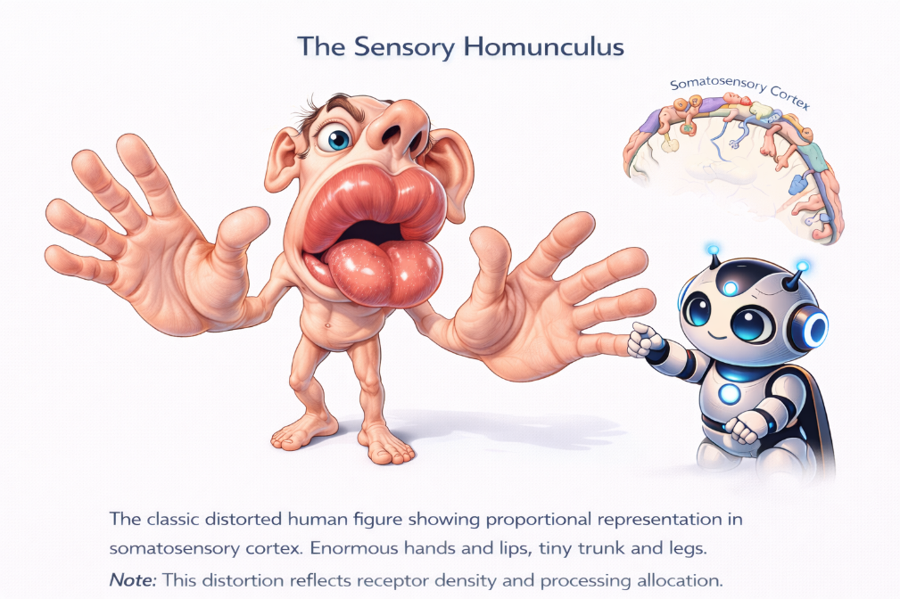

🧠→🤖 AI CONNECTION: Tactile Sensing in Robotics
The somatosensory system is directly relevant to robotics and haptics:

Robotic grippers need tactile feedback to handle objects without crushing or dropping them. Modern tactile sensors (like GelSight and BioTac) mimic the multiple receptor types in human skin — some detect pressure, others detect vibration, others detect slip.

Proprioception is critical for robot control. Without it, a robot arm must rely entirely on vision (slow, imprecise) to know where its joints are. Modern robots use joint encoders (artificial proprioceptors) for fast, accurate motor control.

Pain-inspired signals are used in robotics as safety mechanisms — force thresholds that trigger protective reflexes to prevent damage to the robot or its environment. Collaborative robots (cobots) use this approach to work safely alongside humans.

The homunculus teaches an important design lesson: allocate more sensors where you need more precision. A robotic hand needs dense sensing at the fingertips, not at the wrist.

6.2 The Gustatory System: Taste
Taste (gustation) is a chemical sense — it detects specific molecules dissolved in saliva. Taste receptors are located in taste buds, primarily on the tongue but also on the palate, pharynx, and epiglottis. Each taste bud contains 50-100 taste receptor cells.

There are five established basic tastes, each serving a specific survival function:

Taste | Detects | Survival Function | Example
Sweet | Sugars, some amino acids | Energy-rich food sources | Fruit, honey
Salty | Sodium and other ions | Electrolyte balance | Table salt, sea water
Sour | Acids (hydrogen ions) | Unripe or spoiled food | Lemon, vinegar
Bitter | Alkaloids, toxins | Potential poisons | Coffee, dark chocolate
Umami | Glutamate (amino acid) | Protein-rich food | Meat, mushrooms, soy sauce

Taste information travels via three cranial nerves to the brainstem, then to the thalamus, and finally to the gustatory cortex in the insula and frontal operculum. Unlike other senses, taste is heavily integrated with smell at the cortical level — what we commonly call 'flavor' is actually a combination of taste and olfactory information. This is why food seems bland when you have a cold and your sense of smell is impaired.

An important feature of the gustatory system is hedonic valence — tastes are inherently pleasant or unpleasant. Sweet is universally attractive (even to newborns who have never tasted sugar), while bitter triggers rejection reflexes. This built-in evaluation system guides feeding behavior without requiring learning.

🧠→🤖 AI CONNECTION: Electronic Tongues and Quality Control
Electronic tongues (e-tongues) are sensor arrays designed to mimic gustatory processing. They use arrays of chemical sensors with overlapping sensitivity profiles — similar to how taste receptor cells have partially overlapping response profiles to different molecules.

Applications include: food and beverage quality control (detecting spoilage or contamination), pharmaceutical testing (assessing taste of medications for patient compliance), water quality monitoring, and wine classification.

Machine learning is essential for interpreting e-tongue data: the sensor array produces a complex pattern of responses, and classification algorithms (SVMs, random forests, neural networks) learn to map these patterns to taste categories — just as the gustatory cortex learns to interpret patterns from taste receptors.

The hedonic valence concept has also influenced reinforcement learning. Reward signals in RL function like the innate pleasant/unpleasant evaluation of taste — guiding behavior toward beneficial outcomes and away from harmful ones.

6.3 The Olfactory System: Smell
Olfaction (smell) is the oldest sensory system in evolutionary terms, and it has several unique features that make it fascinating from both a neuroscience and AI perspective.
The olfactory system begins with olfactory receptor neurons in the nasal epithelium. Humans have about 400 types of olfactory receptors (coded by the largest gene family in the human genome), each sensitive to a different range of chemical molecules. When odor molecules bind to these receptors, they trigger electrical signals.
What makes olfaction unique among the senses:
No thalamic relay: Olfaction is the only sensory system that projects directly to the cortex without passing through the thalamus. Olfactory receptor neurons send their axons to the olfactory bulb, which projects directly to the piriform cortex (primary olfactory cortex), the amygdala, and the entorhinal cortex. This direct pathway to the amygdala explains why smells can trigger powerful emotional memories instantly — the famous 'Proustian' phenomenon of a smell transporting you back to a childhood memory.
Combinatorial coding: Humans can distinguish over 1 trillion different odor mixtures using just 400 receptor types. This is possible because each odor activates a unique combination of receptors, and the brain reads the pattern across all receptor types. It is a high-dimensional combinatorial code — not unlike how word embeddings work in NLP, where the meaning of a word is encoded by its position in a high-dimensional vector space.
Sparse, distributed representation: In the piriform cortex, odor representations are sparse — each odor activates only a small fraction of neurons, and each neuron responds to only a small fraction of odors. This sparse coding scheme is highly efficient and is reminiscent of the 'Jennifer Aniston neurons' we discussed in the visual system.

Rapid adaptation: You stop noticing a constant smell within minutes. This is because olfactory neurons adapt quickly to constant stimuli, allowing the system to focus on new or changing chemical signals in the environment. This is adaptation — the olfactory equivalent of the DVS camera from Module 04 that only responds to changes.

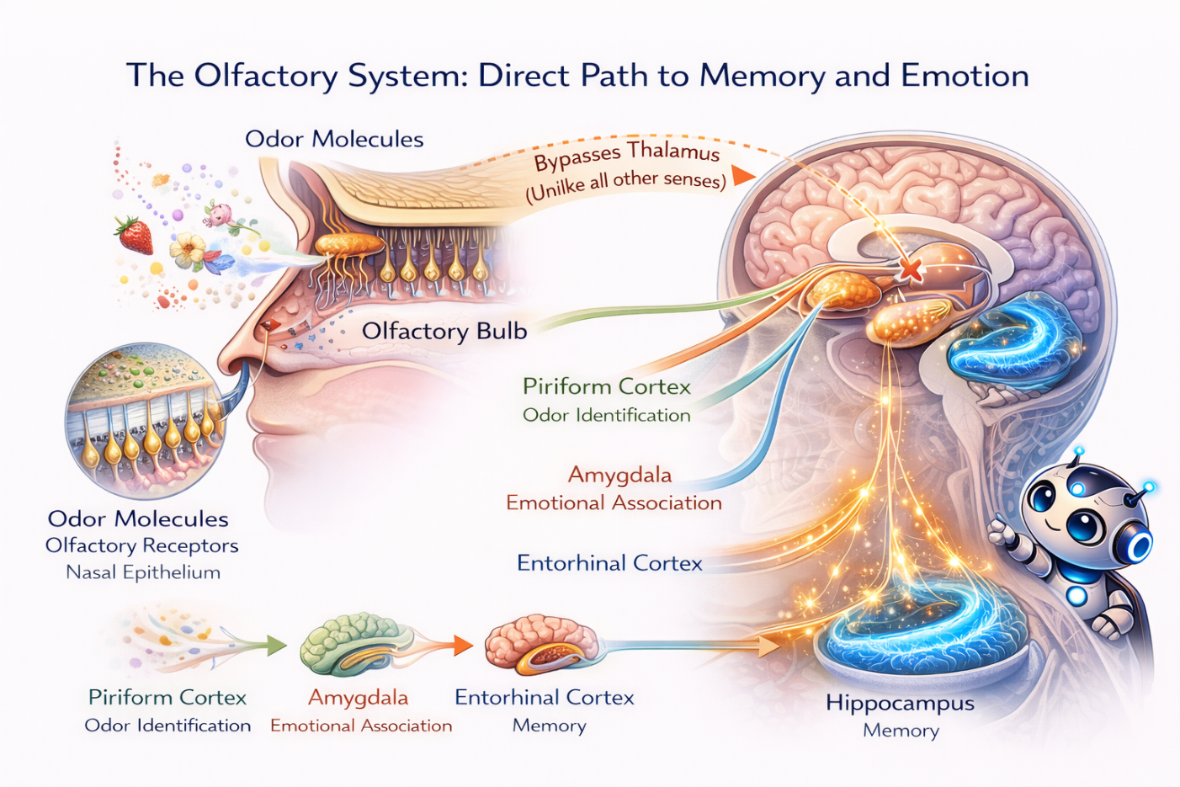

🧠→🤖 AI CONNECTION: Electronic Noses and Molecular AI
Electronic noses (e-noses) use arrays of chemical gas sensors to detect and identify odors. Like the biological system, they rely on pattern recognition across multiple partially-selective sensors rather than one sensor per chemical.

Applications are rapidly expanding: medical diagnostics (detecting diseases from breath — trained dogs can detect cancer; e-noses aim to replicate this), environmental monitoring (air quality, pollution detection), food freshness assessment (detecting spoilage chemicals), explosives and narcotics detection, and industrial process monitoring.

The combinatorial coding of olfaction has inspired a branch of machine learning focused on molecular property prediction. Graph neural networks can now predict the smell of a molecule from its chemical structure — a 2023 Google Research study showed AI could predict odor descriptors (fruity, woody, floral) from molecular graphs more accurately than individual human raters.

The olfactory system's direct connection to memory and emotion has no real AI equivalent yet. Current multimodal AI systems treat all sensory inputs with similar processing — they have no 'fast track' to emotional evaluation. Building AI that can rapidly assess the emotional or survival significance of a sensory input, the way olfaction does, remains an open challenge.

6.4 Comparing All Five Senses
System | Stimulus | Receptor Count | Mapping Type | Unique Feature | AI Application
Vision | Light | 126M / eye | Retinotopy | Highest cortical area (30%) | Computer vision, CNNs
Hearing | Sound waves | 15K / ear | Tonotopy | Best temporal resolution (1ms) | Speech recognition, audio AI
Touch | Pressure, temp. | Millions (skin) | Somatotopy | Multiple submodalities | Haptic robotics, cobots
Taste | Chemicals (mouth) | ~10K taste buds | None (discrete) | Innate hedonic valence | E-tongues, food QC
Smell | Chemicals (air) | ~400 types | Combinatorial | Bypasses thalamus; memory link | E-noses, medical diagnostics

✅ KNOWLEDGE CHECK #2
1. What is tonotopy, and which structure in the ear creates this frequency-to-position mapping?
2. Name two parallel processing streams in the auditory system. What does each process?
3. Why is proprioception essential for robotics? What biological structure provides proprioception?
4. How does olfaction differ from all other sensory systems in its pathway to the cortex? What behavioral consequence does this have?
5. An electronic nose uses an array of partially-selective sensors. Which biological coding principle does this mimic?
(Answers in class discussion)

PART 2
From Biology to AI Systems
Technical — With Code Concepts and Architecture Parallels
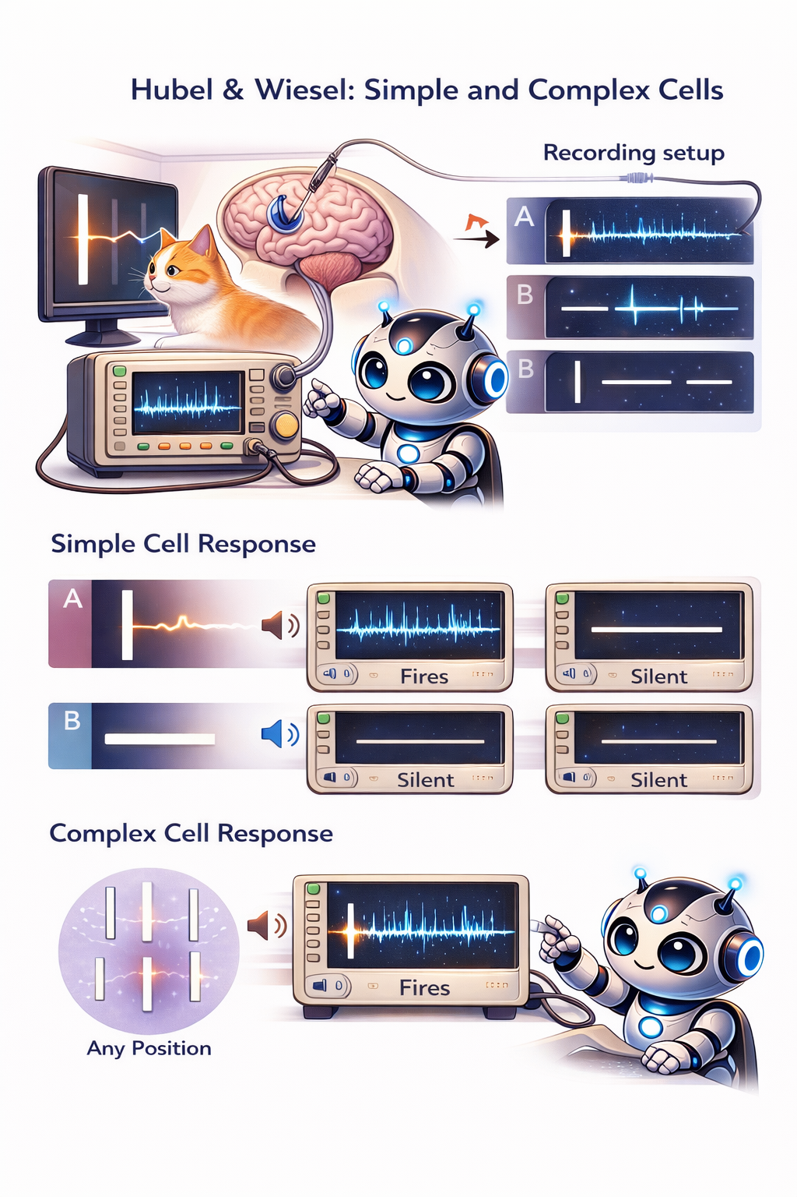
SECTION 7

Hubel & Wiesel → CNNs: The Direct Inspiration
This section tells the most important story in all of bio-inspired AI: how experiments on cat brains in the 1960s led directly to the deep learning revolution of the 2010s. This is not a loose analogy — it is a direct intellectual lineage.

7.1 The Historical Timeline
1962 — Hubel & Wiesel discover simple and complex cells in cat V1. They demonstrate that the visual cortex uses hierarchical feature detection: simple features (oriented edges) are combined into more complex representations.
1980 — Neocognitron (Kunihiko Fukushima) directly cites Hubel and Wiesel. Creates the first neural network with convolutional architecture — alternating layers of 'S-cells' (simple cells = convolution) and 'C-cells' (complex cells = pooling). The Neocognitron could recognize handwritten digits regardless of position.
1989 — LeNet (Yann LeCun) combines the Neocognitron architecture with backpropagation training. LeNet-5 could read handwritten zip codes for the US Postal Service — the first commercially deployed CNN. LeCun explicitly acknowledged the biological inspiration.
2012 — AlexNet (Alex Krizhevsky) wins the ImageNet competition by a massive margin, using deeper CNNs trained on GPUs. This event triggered the deep learning revolution. The architecture — convolutional layers followed by pooling layers followed by fully connected layers — is a direct descendant of Hubel and Wiesel's simple → complex cell hierarchy.
2014 — VGGNet, GoogLeNet, and beyond. Deeper networks with more layers continue the biological principle: each additional layer extracts more abstract features, just as each stage of the visual hierarchy processes more complex information.
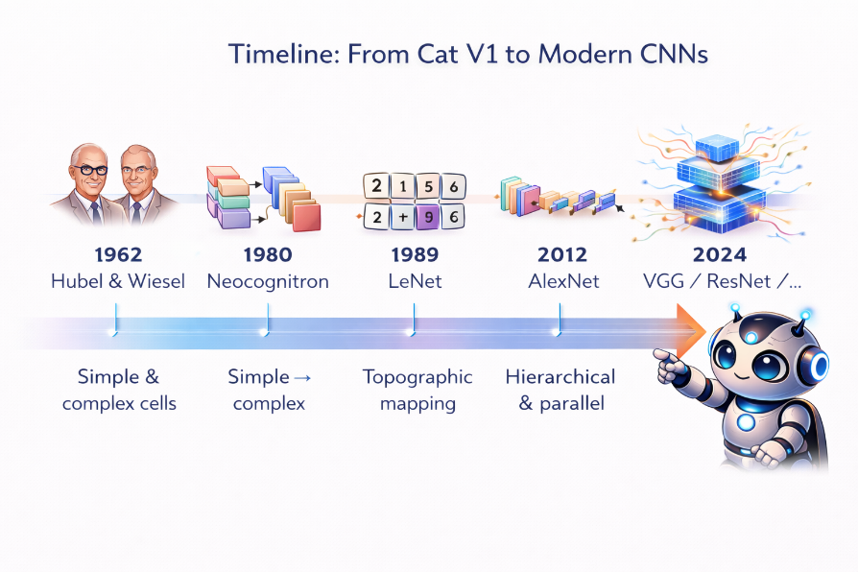

7.2 Feature-by-Feature Mapping
The parallels between the biological visual system and CNNs are precise enough to map feature by feature:
Biological Mechanism | CNN Equivalent | How They Match
Simple cells (V1) | Convolutional filters | Both detect oriented features at specific locations
Complex cells (V1) | Pooling layers | Both provide position invariance over local regions
Hypercomplex cells | No direct equivalent | End-stopping not standard in CNNs
Hierarchy V1→V2→V4→IT | Stacked conv layers | Both extract progressively abstract features
Receptive field growth | Increasing receptive field with depth | Deeper layers see more of the input
Lateral inhibition | Batch norm / local response norm | Both sharpen representations
Ventral stream | Classification networks | Both answer 'what is this?'
Dorsal stream | Spatial/action networks | Both answer 'where and how?'

What is different: Biological vision uses massive recurrence (feedback connections from higher to lower areas), lateral connections within areas, and top-down attention signals. Standard CNNs are purely feedforward — no recurrence, no lateral connections, no top-down feedback. This is likely a major reason why CNN perception is more brittle than human perception. Recurrent neural networks and attention mechanisms are beginning to address this gap.

7.3 Feature Visualization: Seeing What Networks Learn
In 2014, Matthew Zeiler and Rob Fergus published a landmark paper showing that you can visualize what each layer of a CNN has learned. Their method (deconvolutional network visualization) revealed a striking pattern:
Layer 1: Edge detectors and color blobs — almost identical to V1 simple cell receptive fields.
Layer 2: Corners, contours, and texture patterns — similar to V2 responses.
Layer 3: Object parts, repeating patterns — similar to V4 intermediate features.
Layers 4-5: Whole objects and object classes — similar to IT cortex responses.
The CNN discovered the same feature hierarchy that the visual cortex uses — not because it was programmed to, but because this hierarchical decomposition is an effective solution to the problem of visual recognition. Evolution and gradient descent converged on the same answer.
🔑 KEY TAKEAWAY
The convergence between biological and artificial visual processing is the strongest evidence that neuroscience can inform AI design. It was not luck — the visual cortex provided a proven blueprint for hierarchical feature extraction, and CNNs adopted that blueprint. Understanding the biology tells you WHY the architecture works, which helps you design better architectures.

SECTION 8

Event-Based Vision — Silicon Retinas Meet SNNs
Module 04 introduced you to Dynamic Vision Sensors (DVS) as an input source for Spiking Neural Networks. Now we can understand DVS cameras at a deeper level by connecting them to the biological retina.

8.1 How Biological Retinas Inspire Event Cameras
Recall from Section 4.1 that retinal ganglion cells respond to changes in illumination, not to absolute light levels. ON-center cells fire when light increases in their center; OFF-center cells fire when light decreases. A static scene with no changes produces little retinal output — the retina is fundamentally a change detector.
DVS cameras replicate this principle in silicon:
Biological Retina | DVS Camera | Shared Principle
ON-center ganglion cells | Positive polarity events (+1) | Fire when brightness increases
OFF-center ganglion cells | Negative polarity events (-1) | Fire when brightness decreases
Logarithmic adaptation to light | Logarithmic intensity encoding | 120 dB dynamic range
Each cell fires independently | Each pixel fires independently | Asynchronous, event-driven
~1 ms temporal precision | ~1 μs temporal precision | High temporal resolution
Sparse output (only changes) | Sparse output (only changes) | Energy efficiency through sparsity

The full bio-inspired vision pipeline now connects across Modules 04 and 05:
DVS camera (silicon retina) → SNN processing (silicon cortex) → Neuromorphic chip (silicon brain)
This is the most complete bio-inspired AI pipeline that exists today — from sensor to processor, every stage operates on the same event-driven principles that the brain uses.

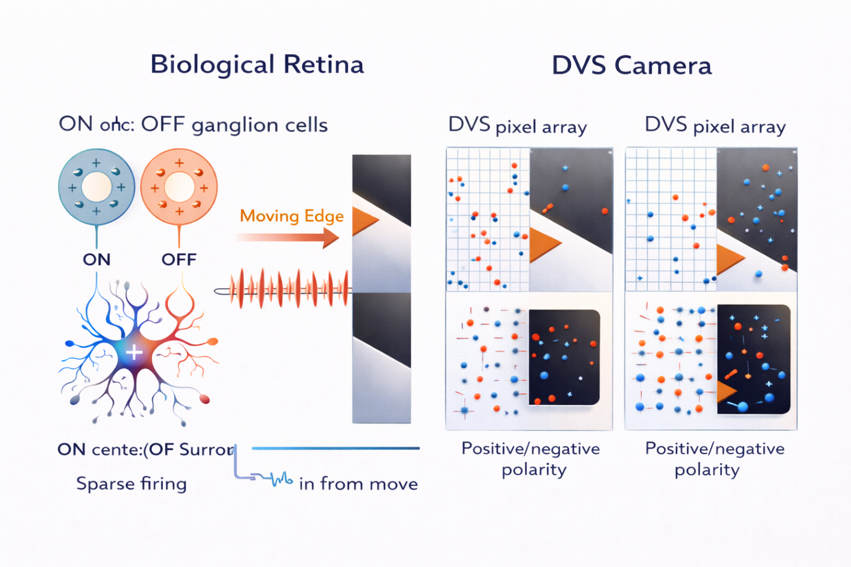

🏭 INDUSTRY CONNECTION
Companies building event-based vision: Prophesee (France, leading DVS manufacturer), iniVation (Switzerland, research-grade DVS), Samsung (integrating DVS into mobile devices), Sony (event sensor for automotive).

Key applications: autonomous vehicles (pedestrian detection at night), industrial robotics (tracking fast-moving parts on assembly lines), drones (obstacle avoidance at high speed), space (star tracking with extreme dynamic range), medical imaging (retinal surgery with microsecond feedback).

✅ KNOWLEDGE CHECK #3
1. Trace the intellectual lineage: What discovery led to the Neocognitron, which led to LeNet, which led to AlexNet?
2. In the CNN-to-visual-cortex mapping table, what biological mechanism corresponds to pooling layers? Why?
3. CNN feature visualization shows that Layer 1 learns edge detectors. Which area of the visual cortex does this correspond to?
4. Name one major difference between biological visual processing and standard CNNs. What AI technique is starting to address this gap?
5. How does a DVS pixel's response to brightness increase parallel a biological ON-center ganglion cell?
(Answers in class discussion)

SECTION 9

Multimodal Integration — Combining the Senses
So far, we have examined each sensory system in isolation. But in the real world, we rarely use just one sense at a time. When you watch a movie, you see images and hear sounds. When you eat, you combine taste, smell, touch (texture), temperature, and even sound (the crunch of a chip). The brain seamlessly integrates information across multiple modalities into a unified experience. Understanding how it does this is critical for building multimodal AI systems.

9.1 How the Brain Integrates Modalities
The Superior Colliculus is one of the earliest integration centers. Located in the midbrain, it contains multisensory neurons — individual neurons that respond to stimuli from multiple modalities (vision + sound, vision + touch, etc.). Barry Stein and colleagues discovered that these neurons follow three rules of integration:
The Spatial Rule: Stimuli from different modalities that come from similar spatial locations are enhanced (their combined response is greater than the sum of individual responses). Stimuli from different locations may be suppressed. This is why you look toward a sound — your brain expects visual and auditory signals to be spatially aligned.
The Temporal Rule: Stimuli that occur close together in time are integrated more strongly. A flash of light and a click of sound presented simultaneously produce a stronger combined response than if they are separated by even a few hundred milliseconds.
The Inverse Effectiveness Rule: Integration is strongest when individual sensory signals are weak or ambiguous. If you can see something clearly, adding sound information helps a little. If you can barely see it (fog, darkness), adding sound helps enormously. The brain relies more heavily on combining senses when individual senses are unreliable.

The McGurk Effect: When Vision Overrides Hearing
The most dramatic demonstration of multimodal integration is the McGurk Effect (1976). When you see a video of someone mouthing 'ga' while the audio plays 'ba,' you perceive 'da' — a sound that is neither the visual nor the auditory signal, but a fusion of both. Your brain automatically combines lip movements (vision) with speech sounds (hearing) to construct a unified percept, even when the signals conflict.

This shows that perception is not just about one sense providing information — the brain actively integrates and sometimes overrides individual sensory signals based on reliability and context. Speech perception, in particular, is inherently audiovisual for most people.

🔬 TRY THIS: Experience the McGurk Effect
Search YouTube for 'McGurk Effect demonstration.' Watch the video with your eyes open — you will hear one sound. Then close your eyes and replay it — you will hear a completely different sound. Same audio, different perception, depending on whether your brain can integrate the visual information.

This is one of the most convincing demonstrations that perception is constructed, not received.

9.2 Multimodal AI Systems
AI multimodal systems are one of the most active research areas in AI today. Here is how they compare to biological integration:

Approach | How It Works | Biological Parallel
CLIP (OpenAI) | Learns shared embedding space for images and text | Similar to how multisensory neurons create modality-invariant representations
GPT-4V / Gemini | Process images and text in unified transformer | Cortical integration in association areas
Audio-visual speech | Combine spectrograms + lip movements | Direct parallel to McGurk-style integration
Sensor fusion (AV) | Camera + LiDAR + radar for driving | Superior colliculus combining vision + sound + touch
Multimodal emotion | Face + voice + text for sentiment | Amygdala integrating multiple modality inputs

9.3 The Binding Problem
One of the deepest unsolved problems in neuroscience is the binding problem: How does the brain combine distributed representations across different sensory areas and different features (color, shape, motion, sound) into a unified, coherent experience?
When you see a red ball bouncing with a thud, the color (V4), shape (IT), motion (MT), and sound (A1) are processed in completely different brain areas. Yet you experience a single unified event — a red bouncing ball that thuds. How?
Proposed solutions include temporal synchrony (features belonging to the same object fire in synchrony), attention (the spotlight of attention binds features together), and the global workspace theory (information is bound when it is broadcast across the cortex in a shared workspace).

🧠→🤖 AI CONNECTION: AI Has Not Solved Binding Either
Current multimodal AI systems mostly concatenate or cross-attend features from different modalities. They do not truly 'bind' them into unified representations the way the brain does.

A CLIP model can associate an image with text, but it does not maintain a unified object-level representation where visual features (color, shape), auditory features (sound), and semantic features (name, function) are bound into a single coherent entity.

Solving the binding problem — in both neuroscience and AI — could lead to more robust and generalizable multimodal systems. This is a frontier where neuroscience insights could directly inspire AI breakthroughs.

SECTION 10

What Biology Does Better (And Where AI Excels)

10.1 Biological Advantages
Robustness: You can recognize a friend in fog, rain, at night, from behind, or after they change their hairstyle. Biological perception gracefully degrades under adverse conditions. AI perception can fail catastrophically from a few changed pixels (adversarial attacks).
Energy efficiency: The entire human visual system runs on about 10 watts. A single GPU running a vision model uses 300+ watts. Neuromorphic approaches (Module 04) are closing this gap.
One-shot learning: You can recognize a new animal after seeing it once. CNNs typically need thousands of examples. Few-shot learning in AI is improving but still far from biological performance.
Context and common sense: You know that a car on a ceiling is unusual, that a dog in a kitchen is normal, and that a shadow does not change an object's identity. Biological perception uses rich world knowledge. AI systems are beginning to incorporate this through large language models and vision-language models.

10.2 AI Advantages
Speed on large datasets: AI can analyze millions of medical images, satellite photos, or audio recordings in hours. A human could not process this volume in a lifetime.
Consistency: AI does not get tired, distracted, or biased by recent experience. A diagnostic AI gives the same analysis at 3 AM as at 3 PM.
Beyond-human sensing: AI can process infrared, ultraviolet, radio waves, ultrasound, and other signals that are invisible to human senses. Multispectral satellite imagery combines dozens of wavelengths no human eye can see.
Scalability: You can deploy thousands of AI sensors simultaneously. You cannot hire thousands of experts to monitor every security camera or every piece of industrial equipment.

🔑 KEY TAKEAWAY
The goal is not to decide which is 'better' — biological or artificial perception. The goal is to understand both well enough to combine their strengths. Neuromorphic sensors (DVS cameras) bring biological efficiency to AI. Large-scale AI processing brings scalability to tasks inspired by biological perception. The most powerful systems of the future will draw from both traditions.
✅ KNOWLEDGE CHECK #4
1. Name the three rules of multisensory integration discovered in the superior colliculus.
2. In the McGurk Effect, what happens when you see 'ga' lip movements with 'ba' audio? What does this demonstrate about perception?
3. What is the binding problem? Why is it relevant to multimodal AI?
4. Name two things biological perception does better than AI, and two things AI does better.
(Answers in class discussion)

SECTION 11

Lab Preview — Bio-Inspired Perception Pipeline
💡 LAB CONCEPT: FROM RETINA TO RECOGNITION
This lab builds a bio-inspired visual processing pipeline step by step, allowing you to see how each stage of the visual hierarchy transforms an image — and compare it directly with what a CNN learns on its own.

11.1 Python Lab: Bio-Inspired Perception Pipeline
In this lab, you will build and compare two image processing pipelines side by side — one that mimics biological visual processing, and one that uses a pre-trained CNN. The goal is to see the parallels firsthand.
Part A — Retinal Processing (Center-Surround Filtering)
You will implement a center-surround filter using the Difference of Gaussians (DoG) — a mathematical approximation of what retinal ganglion cells compute. Apply it to sample images and observe how it extracts edges and ignores uniform regions — exactly what the retina does before sending information to the brain.
Part B — V1 Processing (Gabor Filter Bank)
You will create a bank of Gabor filters at multiple orientations and spatial frequencies — these are mathematical models of V1 simple cells. Apply the filter bank to images and visualize which orientations and frequencies each part of the image activates. This is what V1 does: decomposing the visual scene into oriented edge components.
Part C — CNN Comparison (First-Layer Feature Visualization)
Load a pre-trained CNN (such as VGG-16 or ResNet-18) and extract the learned filters from its first convolutional layer. Visualize these filters and compare them to your hand-crafted Gabor filter bank. You will see that the CNN independently discovered filters that look remarkably similar to V1 simple cells — oriented edges at multiple orientations.
Part D — Hierarchical Activation Maps
Feed an image through the pre-trained CNN and extract activation maps at different layers (early, middle, late). Compare: early layers show edge-like responses (V1), middle layers show texture and shape patterns (V2/V4), and late layers show object-level activations (IT). Map each layer to its biological counterpart.
Part E — Reflection Questions
Analyze your results: Where do the biological and artificial approaches converge most closely? Where do they diverge? What features does the CNN learn that have no clear biological parallel? What does the biological system do that the CNN cannot?

Tools: PyTorch (pre-trained models), OpenCV (image filtering), NumPy, Matplotlib. All work in Google Colab — no special hardware needed.

SECTION 12

Key Takeaways

1 Sensory systems share common organizational principles — transduction, hierarchical processing, parallel pathways, topographic mapping, lateral inhibition, and top-down modulation — despite processing completely different types of physical energy. These are fundamental principles for effective information processing.
2 The visual cortex directly inspired CNNs — this is the clearest and most impactful brain-to-AI success story. Simple cells = convolutional filters, complex cells = pooling, visual hierarchy = network depth. Understanding the biology tells you why the architecture works.
3 All five senses inspire distinct AI applications — vision (computer vision), hearing (speech and audio AI), touch (haptic robotics), taste (electronic tongues for quality control), and smell (electronic noses for diagnostics). Each sense solved a different engineering problem, and AI can learn from each solution.
4 Multimodal integration remains a frontier — the brain integrates senses using principled rules (spatial, temporal, inverse effectiveness). AI multimodal systems are improving rapidly but have not solved the binding problem. This is where neuroscience insights could unlock the next breakthrough.
SECTION 13

Bridge to Module 06 — Memory, Learning, and AI Architectures

🌉 WHAT COMES NEXT
Module 05 explored how the brain takes in information from the world — through five sensory systems that transduce, filter, and hierarchically process physical energy into neural representations.

But perception is only half the story. Once information is perceived, the brain must STORE it, RETRIEVE it, and LEARN from it. This is the domain of memory.

Module 06 will explore:
• Types of biological memory: working memory, episodic, semantic, procedural
• The hippocampus and memory consolidation — why you need sleep to learn
• How the hippocampus 'replays' the day during sleep — and how Deep RL uses the exact same idea (experience replay)
• AI memory architectures: LSTMs, transformers, memory-augmented neural networks
• The biological plausibility debate: backpropagation vs. Hebbian learning

Here is a teaser: Your brain replays your day while you sleep — neurons fire in the same patterns they fired during waking experience, but compressed in time. In 2015, DeepMind used this exact biological principle (experience replay) to build DQN, the first AI to play Atari games at superhuman level. The hippocampus literally inspired the technique that launched the deep reinforcement learning revolution.

SECTION 14

Glossary

Basilar membrane: Structure in the cochlea that vibrates at different positions for different frequencies, creating tonotopic organization.
Binding problem: The unsolved question of how the brain combines distributed sensory features into unified perceptual experiences.
Center-surround receptive field: A retinal ganglion cell pattern where the center and surround respond oppositely to light — the basis of biological edge detection.
Cochlea: Snail-shaped inner ear structure that converts sound vibrations into neural signals via hair cells on the basilar membrane.
Complex cell: V1 neuron that responds to oriented edges regardless of position — provides translation invariance. Corresponds to CNN pooling.
Dorsal stream: The 'where/how' visual pathway from V1 to parietal cortex, processing spatial location and action guidance.
DVS (Dynamic Vision Sensor): Silicon retina where each pixel fires events on brightness change, mimicking retinal ganglion cell behavior.
Electronic nose (e-nose): Sensor array that detects odors using multiple partially-selective chemical sensors and pattern recognition.
Electronic tongue (e-tongue): Sensor array for liquid chemical analysis, used in food quality control and pharmaceutical testing.
Gabor filter: Mathematical model of V1 simple cell receptive fields — detects oriented spatial frequencies. Used in bio-inspired image processing.
Gustation: The sense of taste, detecting dissolved chemicals via taste receptors (sweet, salty, sour, bitter, umami).
Homunculus (sensory): Distorted body map in somatosensory cortex reflecting receptor density — large hands and lips, small trunk.
Inferotemporal cortex (IT): End of the ventral visual pathway; neurons respond to whole objects, faces, and concepts.
Inverse effectiveness: Rule of multisensory integration: combining senses helps most when individual signals are weak.
Lateral Geniculate Nucleus (LGN): Thalamic relay station for visual information, with magnocellular (motion) and parvocellular (detail) channels.
Lateral inhibition: Neurons suppressing their neighbors' activity to sharpen contrasts and enhance edges.
McGurk Effect: Perceptual illusion where visual lip movements change what you hear — demonstrates audiovisual integration.
Olfaction: The sense of smell, using ~400 receptor types with combinatorial coding to distinguish trillions of odors.
Perception: The brain's active, constructive interpretation of sensory signals — not passive reception.
Proprioception: The sense of body position and movement, using muscle spindles and Golgi tendon organs.
Retinotopy: Spatial mapping in visual cortex where nearby visual field positions are processed by nearby neurons.
Sensation: Raw transduction of physical energy into neural signals at sensory receptors.
Simple cell: V1 neuron that responds to oriented edges at specific positions — corresponds to CNN convolutional filters.
Somatosensory system: Combined system for touch, pressure, temperature, pain, and proprioception.
Tonotopy: Frequency mapping in auditory cortex where nearby frequencies are processed by nearby neurons.
Top-down modulation: Feedback from higher to lower brain areas shaping perception based on expectations and attention.
Transduction: Conversion of physical energy (light, sound, pressure, chemicals) into electrical neural signals.
Ventral stream: The 'what' visual pathway from V1 through V4 to inferotemporal cortex, processing object identity.

SECTION 15

References & Further Reading

Key Papers
Hubel, D.H. & Wiesel, T.N. (1962). Receptive fields, binocular interaction and functional architecture in the cat's visual cortex. Journal of Physiology, 160(1), 106-154.
Goodale, M.A. & Milner, A.D. (1992). Separate visual pathways for perception and action. Trends in Neurosciences, 15(1), 20-25.
Quiroga, R.Q. et al. (2005). Invariant visual representation by single neurons in the human brain. Nature, 435, 1102-1107.
Zeiler, M.D. & Fergus, R. (2014). Visualizing and understanding convolutional networks. European Conference on Computer Vision (ECCV).
Stein, B.E. & Stanford, T.R. (2008). Multisensory integration: current issues from the perspective of the single neuron. Nature Reviews Neuroscience, 9, 255-266.
Feichtenhofer, C. et al. (2019). SlowFast networks for video recognition. IEEE/CVF International Conference on Computer Vision (ICCV).
Gallego, G. et al. (2020). Event-based vision: A survey. IEEE Transactions on Pattern Analysis and Machine Intelligence.
McGurk, H. & MacDonald, J. (1976). Hearing lips and seeing voices. Nature, 264, 746-748.
Lee, A. et al. (2023). A principal odor map unifies diverse tasks in human olfactory perception. Science, 381(6661).
Hassabis, D. et al. (2017). Neuroscience-inspired artificial intelligence. Neuron, 95(2), 245-258.

Recommended Books
Kandel, E.R. et al. — Principles of Neural Science (6th ed.) — Chapters on sensory systems
Hawkins, J. — A Thousand Brains — Chapters on cortical columns and sensory processing
Goodfellow, I. et al. — Deep Learning — Chapter 9 (CNNs) for the AI side of the story
Gazzaniga, M.S. — Cognitive Neuroscience — Chapters on perception and multisensory integration

